Mathematics and knowledge
TOK math guest lecture by Mr. Chase

- Is mathematics Invented or Discovered? - Aristotle vs. Plato
- The beauty of mathematics - Why do mathematicians do what they do?
- What parts of mathematics are we free to invent? - Formalism
- The usefulness of mathematics - Why does mathematics ‘work’?
- A justification of math education - A liberal education

Jokes & Quotes

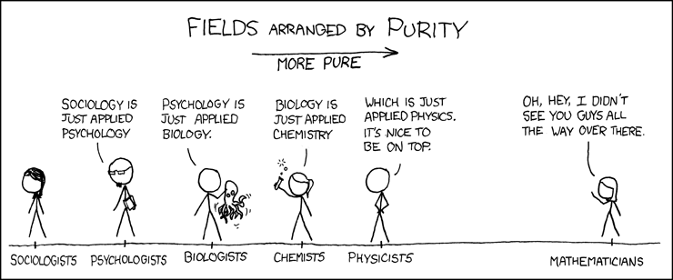

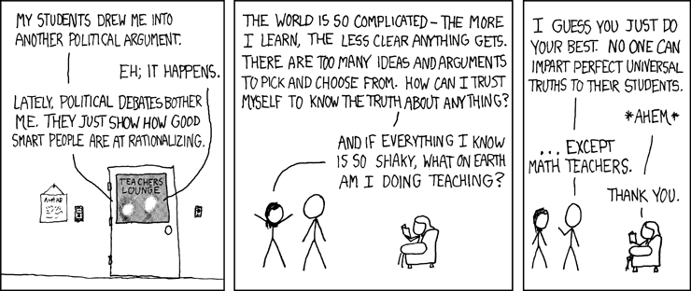
<taken from xkcd.com>

“Mathematics is a queen of science.” - Carl Friedrich Gauss
“Some of you may have met mathematicians and wondered how they got that way.” - Tom Lehrer
“Wherever there is number, there is beauty.” - Proclus
“It is impossible to be a mathematician without being a poet in soul.” - Sofia Kovalevskaya
“The mathematician does not study pure mathematics because it is useful; he studies it because he delights in it and he delights in it because it is beautiful.” - Jules Henri Poincaré
“Mathematics is a game played according to certain simple rules with meaningless marks on paper.” - David Hilbert

“It’s like a gorgeous painting that also functions as a dishwasher!” – Ben Orlin

