Mathematics and knowledge
TOK math guest lecture by Mr. Chase

Is Mathematics Invented or Discovered?

Classic question in the philosophy of mathematics, that maybe you've already thought about or talked about in this class:

Is mathematics invented or discovered?

Poll: Here are your options:
- Invented
- Discovered
- Unresolvable
- I don’t know

[Give a minute for students to think, then have them raise hands and tally the vote.] Keep in mind the options I’ve allowed for in this poll because they might foreshadow something later in this talk. [the notion of undecidable statements]

Here are the typical arguments on both sides of the issue.

Invented: Aristotle would have been in this camp. People say things like “Newton and Leibniz invented Calculus.” Someone invents a new algorithm for something. Surely long division was invented, not discovered, you would say. Surely we came up with our number system and we invented all the conventions and symbols we use. And, to counter those who might claim that mathematics is discovered: if a mathematical theory goes undiscovered, does it truly exist? (If a tree falls in the woods…)

Discovered: Plato would have been in this camp. Is $2^{67}-1$ a prime or composite? (In 1903, Frank Nelson Cole proved it was composite in a famous lecture without words, simply by writing the factors on the board and multiplying it out. It was actually known to be composite since 1876...that’s almost 30 years of no one knowing the factors!) Many people didn't know for years, even though clearly there’s an answer. Once it was known, I think we might say it was discovered. Is the twin prime conjecture true? [have a student define what twin primes are, if a student is able.] Well, someone will invent a proof, but its truth is itself transcendent. This is an example of something still yet to be discovered. Actually, progress on this particular question has been made in the last year!

[Handout – outline of the talk/quotes/jokes]

The beauty of mathematics—or “why discovered is the right answer to the first question” :-)

[Show this Geogebra applet with quadrilateral parallelogram theorem interactively...then ask kids if this is a coincidence. Can they prove it? It's either true or false. But you have an insatiable desire to try to prove it—a hole in your mathematical heart!] [Is $9^{n}-1$ always divisible by 8?][How can you prove that two people in DC have the same number of hairs on their heads?][talk about existence proofs vs. constructive proofs, if time allows]

Make no mistake, I am in Plato’s camp on this one. I think mathematics is discovered. The mathematics that we think of as having been ‘invented’ is merely a shadow of the true mathematics, projected into our temporal reality (to borrow Platonist language). Mathematics is pure.

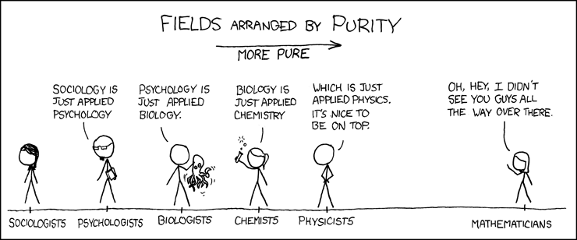
<taken from xkcd.com>

“Mathematics is a queen of science.” - Carl Friedrich Gauss

You see, math is about beauty and purity. That realization is what turns young, unsuspecting students into mathematicians. “Some of you may have met mathematicians and wondered how they got that way.” - Tom Lehrer :-) How do you know when a mathematician is hard at work? If you walk into the halls of a math department and see one mathematician busily working on his computer typing up a paper or working on a lecture, he is not actually doing work. If you see another mathematician staring out the window, he is the one hard at work!

No, really, it’s true. Mathematicians do mathematics because it is beautiful, regardless of whether it might also be useful:
  - “Wherever there is number, there is beauty.” - Proclus (add to that logic, variable, and proof…not just number)
  - “It is impossible to be a mathematician without being a poet in soul.” - Sofia Kovalevskaya
  - “The mathematician does not study pure mathematics because it is useful; he studies it because he delights in it and he delights in it because it is beautiful.” - Jules Henri Poincaré
In some ways, it provides a safe harbor from the disorder and chaos of the real world. Math is so pure and certain that we can avoid the debates and deconstructionism that plagues so many other academic areas:

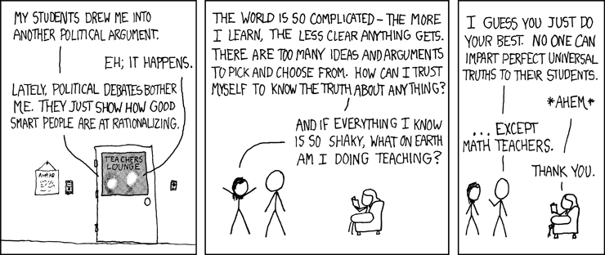
<taken from xkcd.com>

Yes, I'm in the discovered camp when it comes to the opening question. Math has always been the same. If you were to go to a different planet, math would still be the same (maybe different axiom systems, maybe they would use a different base, and they would of course use different symbols, but they would arrive at the same mathematics, and the same theorems). People say “math hasn't changed in 30 years since when I was in school.” True. It's worse than that, actually. It hasn't changed in 4.6 billion years! That's one reason why math is so beautiful, so austere.

What parts of mathematics are we free to invent?
“Our base ten number system was invented.” I completely agree. But the beauty of math is that the base in which we do it doesn’t actually matter. All of our theorems still work in other bases. The choice of base is arbitrary. Our symbols are arbitrary.

This bridges us to the notion of formalism:

“Mathematics is a game played according to certain simple rules with meaningless marks on paper.” - David Hilbert

Hilbert’s quote might seem funny to you, but it’s a perfect description of mathematics. At one time, it seemed that mathematics was immutable. You might say “1+1=2” is founded in reality—it’s an immutable, unchangeable reality over which you have no say. But mathematicians have a slightly broader view than that. We set up axiom systems and then using simple sets of axioms, we prove a whole host of results. Generally, we want these rules to confirm our intuitions and reflect truth in the outside world in a meaningful way, but this isn’t necessary. For example, all of the rules of algebra that you know and love are based on just a small set of axioms, called the Field Axioms (taken from Wikipedia):

[Handout – field axioms and Rudin proofs]

Closure of F under addition and multiplication
For all a, b in F, both a + b and a · b are in F (or more formally, + and · are binary operations on F).
Associativity of addition and multiplication
For all a, b, and c in F, the following equalities hold: a + (b + c) = (a + b) + c and a · (b · c) = (a · b) · c.
Commutativity of addition and multiplication
For all a and b in F, the following equalities hold: a + b = b + a and a · b = b · a.
Existence of additive and multiplicative identity elements
There exists an element of F, called the additive identity element and denoted by 0, such that for all a in F, a + 0 = a. Likewise, there is an element, called the multiplicative identity element and denoted by 1, such that for all a in F, a · 1 = a. To exclude the trivial ring, the additive identity and the multiplicative identity are required to be distinct.
Existence of additive inverses and multiplicative inverses
For every a in F, there exists an element −a in F, such that a + (−a) = 0. Similarly, for any a in F other than 0, there exists an element a⁻¹ in F, such that a · a⁻¹ = 1. (The elements a + (−b) and a · b⁻¹ are also denoted a − b and a/b, respectively.) In other words, subtraction and division operations exist.
Distributivity of multiplication over addition
For all a, b and c in F, the following equality holds: a · (b + c) = (a · b) + (a · c).

These are the “simple rules” with which we “play the game” of mathematics. From these simple axioms, the notion of subtraction and division can be derived, the notion of exponents & logarithms, and roots. This is the entire subject of interest in an analysis course, if you have the privilege of taking one someday. For example, people wonder why a negative times a negative is a positive. Here’s the answer: We can prove it from the field axioms! If we don’t define it that way, we get contradictions. This, to me, is a much more powerful and appealing argument than those who try to justify it with real world situations. This becomes true for so many other similar questions too—why can’t we divide by zero? why is it true that 0 times any number is 0? or 1 times any number is itself? why is a number raised to the zero power equal to 1? In all of the answers to these questions, our hand is forced by our set of axioms (which, I remind you, we freely chose).

Proposition 1.14 from Rudin. The axioms for addition imply the following statements.

- If $x+y=x+z$ then $y=z$ (cancellation)
- If $x+y=x$ then $y=0$ (uniqueness of the additive identity)
- If $x+y=0$ then $y=-x$ (uniqueness of the additive inverse)
- $-\left(-x\right)=x$ (double negation)

Proof. If $x+y=x+z$, the axioms for addition give

$$y=0+y=\left(-x+x\right)+y=-x+\left(x+y\right)=-x+\left(x+z\right)=\left(-x+x\right)+z=0+z=z.$$

This proves (a). Take $z=0$ in (a) to obtain (b). Take $z=-x$ in (a) to obtain (c). Since $-x+x=0$, (c) (with $–x$ in place of $x$) gives (d).$∎$

Proposition 1.15 from Rudin. The axioms for multiplication imply the following statements.

- If $x≠0$ and $xy=xz$ then $y=z$ (cancellation)
- If $x≠0$ and $xy=x$ then $y=1$ (uniqueness of the multiplicative identity)
- If $x≠0$ and $xy=1$ then $y=1/x$ (uniqueness of the multiplicative inverse)
- If $x≠0$ then $1/(1/x)=x$.

Proposition 1.16 from Rudin. The field axioms imply the following statements, for any $x$, $y$, and $z∈F$.

- $0x=0$.
- If $x≠0$ and $y≠0$ then $xy≠0$.
- $\left(-x\right)y=-\left(xy\right)=x(-y)$.
- $\left(-x\right)\left(-y\right)=xy$

Proof. $0x+0x=\left(0+0\right)x=0x$. Hence 1.14(b) implies that $0x=0$, and (a) holds. Next, assume $x≠0$, $y≠0$, but $xy=0$. Then (a) gives

$$1=\left(\frac{1}{y}\right)\left(\frac{1}{x}\right)xy=\left(\frac{1}{y}\right)\left(\frac{1}{x}\right)0=0$$

a contradiction. Thus (b) holds. The first equality in (c) comes from

$$\left(-x\right)y+xy=\left(-x+x\right)y=0y=0,$$

combined with 1.14(c); the other half of (c) is proved in the same way. Finally,

$$\left(-x\right)\left(-y\right)=-\left[x\left(-y\right)\right]=-\left[-\left(xy\right)\right]=xy$$

by (c) and 1.14(d).$∎$

[Pass out analysis textbooks for students to skim]

If you want to break any of the field axioms, you may. You just can’t call the algebraic structure that you’re working with a field. For example, the absence of multiplicative inverses gives rise to the notion of a ring, which is also a very important idea in mathematics (albeit one you won’t encounter in high school).

[Pass out algebra textbooks for students to skim]

Well-formed formulas. “The tidy love perforates machines.” “Thrh emme ajajaj” “Three and five are twenty.” are all wrong, but for very different reasons (semantics, syntax,...) [struck for the sake of time]

Kurt Gödel proved some path-breaking results in mathematical logic. He showed that in any axiom system, there will always remain statements that you cannot prove true or false. For example:

Axioms: “it is raining outside.”
“if it is raining, I will take an umbrella”

Statements: “I will take an umbrella.” – provably true in this axiom system
“It is not raining outside.” – provably false in this axiom system
“If it is raining, I will bring my pet hamster as well.” –undecidable in this axiom system

Okay, then, you might say, “let’s just expand the axiom system until it can speak about hamsters.” You can try to do that, but what Gödel showed is that this is a fool’s errand. You can try to expand your axiom system so that your system is complete—that is, every statement can be assigned a value of true or false—but then your system will necessarily be inconsistent.

At one time, mathematicians hadn’t really encountered such ‘undecidable’ statements in mathematics. But now, thanks to Gödel’s work, we know of many: The Continuum Hypothesis, The Axiom of Choice, Hilbert’s Tenth Problem, and The Halting Problem. So mathematicians, now, are interested in three types of results when considering a conjecture: Provably true, provably false, or undecidable.

If a statement is undecidable, this also means that we can choose the statement to be true or false and in either case it will be consistent with all the other statements in the system.

Furthermore, he proved that if an axiom system is complete (that is, we avoid all undecidable statements), then it necessarily has internal inconsistencies.

[Pass out Rebecca Goldstein’s book Incompleteness]

The usefulness of mathematics

“It’s like a gorgeous painting that also functions as a dishwasher!” – Ben Orlin

Mathematics just happens to also be useful. But its correlation to the real world is actually quite unreasonable. Why should it be true that when we play with math in a sterile room and discover interesting mathematics, that it apply to or describe the real world at all?? It’s really mind-blowing.

The fact that mathematics so accurately describes the real world is more support for the Platonic view. We invent notation, true. But the actual mathematics describes real world phenomenon—like the interaction of particles or the growth of populations. We would certainly agree that these other aspects of reality—biology, chemistry, and physics—are discovered. People discover atoms, then they invent a name for them.

A justification of math education

Many educational reformers would want you to learn math because it prepares you for a future working for SpaceX or decrypting state secrets at the NSA. This is true. Mathematics provides an excellent foundation for a cadre of high-powered careers that reward mathematical intelligence.

But in my opinion, the reason math is important for you to learn is because it is beautiful and interesting, not necessarily because it is useful. Our goal as math teachers is to provide you with a liberal education (meaning, one that frees you) so that you can appreciate the beautiful things and engage in intelligent conversation with all kinds of people. Some people think the goal of education is to make you a good citizen, to make you successful or rich, or to land you a job. But I have a slightly more religious motivation...it’s so that you’ll glimpse the mind of God!

In reality, 99% of you won’t directly use any of the math you learn. Depressing? It shouldn’t be. The same is true for all your other high school subjects. We’re giving you a liberal education.

Conclusion
Math is pure, beautiful, certain. And by “math” we also mean logic, formal systems, games, rules, reasoning, argument. It is discovered, not invented, though our notation and many other structures are invented arbitrarily. Unlike other arenas, we can truly be certain with math in ways that no other subject can enjoy.

