Graph $y≤5x^{2}+3$.
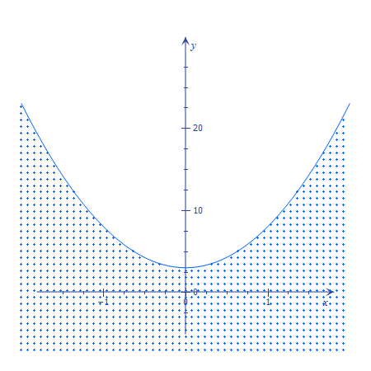
Solve $e^{x}=52$.
$$x=\ln\left(52\right)$$
Expand ${\left(x+5\right)}^{7}$.

$$x^{7}+35 x^{6}+525 x^{5}+4375 x^{4}+21875 x^{3}+65625 x^{2}+109375 x+78125$$

Evaluate $\int{x e^{x^{2}}ⅆx}$.
$$\frac{e^{x^{2}}}{2}+С$$

Differentiate $\frac{x-4}{\left(x+4\right) \left(x+7\right)}$.
$$\frac{72+8 x-x^{2}}{x^{4}+22 x^{3}+177 x^{2}+616 x+784}$$

Find inverse of $\left[\begin{matrix}4 & 3 \\ -1 & 2\end{matrix}\right]$.
$$\left(\begin{matrix}\frac{2}{11} & -\frac{3}{11} \\ \frac{1}{11} & \frac{4}{11}\end{matrix}\right)$$
Expand $\left(x+2\right)\left(x-4\right){\left(x+5\right)}^{2}$.
$$x^{4}+8 x^{3}-3 x^{2}-130 x-200$$

Factor $x^{4}+8 x^{3}-3 x^{2}-130 x-200$.
$$\left(x-4\right) \left(x+2\right) {\left(x+5\right)}^{2}$$

Sort $\left\{1,2,90,5,-6,14,0,25,34,-50,24\right\}$.
$$\left\{-50, -6, 0, 1, 2, 5, 14, 24, 25, 34, 90\right\}$$

Variance
$$\frac{126088}{121}$$
Sum
$$139$$
Median
$$5$$
Solve $\frac{\left(x^{2}-13x+40\right)\left(x^{2}-13x+42\right)}{\sqrt{x^{2}-12x+35}}=0$ over $R$.
$$x=8 or x=6$$
Solve $\frac{\left(x^{2}-13x+40\right)\left(x^{2}-13x+42\right)}{\sqrt{x^{2}-12x+35}}=0$ over $C$.
$$x=8 or x=6$$

Graph $z=x^{2}+y^{2}$
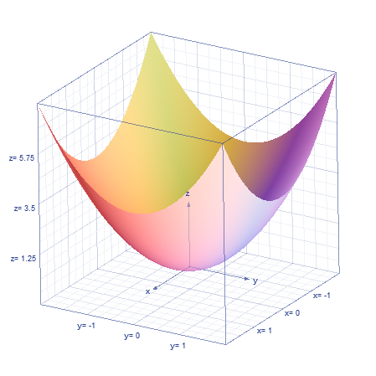
Graph $z=\sin\left(x+y\right)+cos⁡(x+y)$

Graph $x^{2}=2^{x}$
Solve $x^{2}=2^{x}$
$$x≈2$$
(obviously there are THREE solutions, but it only got one)
Graph all of these.
$$y=\sin\left(x\right) \\ y=x \\ y=x-\frac{x^{3}}{3!} \\ y=x-\frac{x^{3}}{3!}+\frac{x^{5}}{5!}$$

You have power over some graph features (window, zoom, tracing, etc) but not over others (color of graphs, line thickness, axis labels & increments, and other style features).

